Robot Operation Document

This document is based on basic usage of teach pendant for controlling robot movements. It particularly covers the following topics:

* Starting of Robot
* Robot Homing Procedure
* Running teach pendant program
* Operator Box usage

# **Starting of Robot**

1. Switch on the main power supply.
2. Switch on the power supply to the robot controller by turning the red knob in clockwise direction.

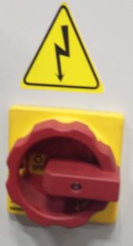

1. Press “Controller on” (green color button on the controller). Note: In case, green light doesn’t get on then check emergency stop buttons (red color) on the controller, operator box and the teach pendant. They should be released (move in anti-clockwise direction) to switch on the supply to the controller.

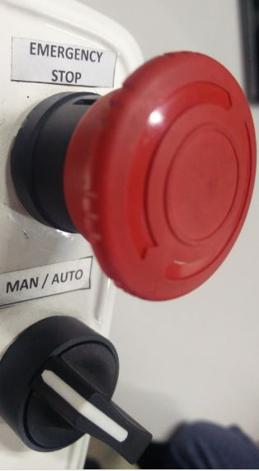 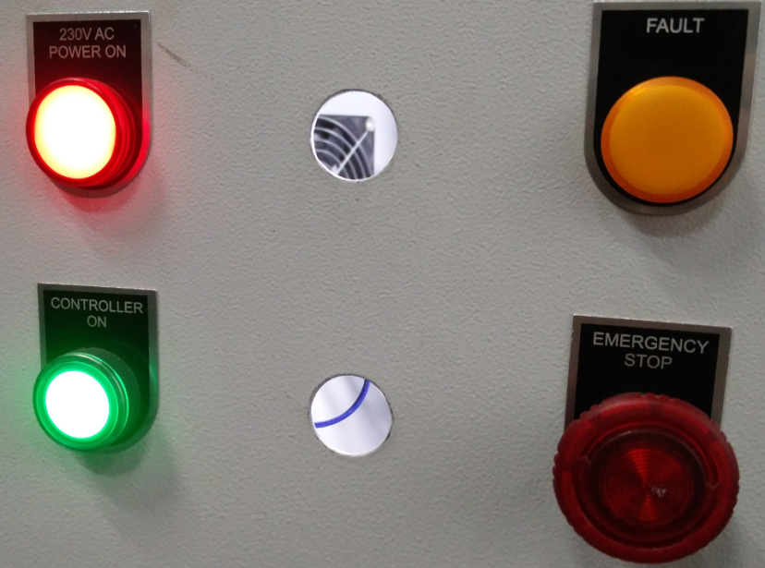

1. Press “Reset” button on controller to disengage brakes of the motor.
2. Now, you can start operating the teach pendant.

# **Robot Homing Procedure**

**Steps required for robot homing are as follow:**

1. When switching the controller on for the first time, rotate the knob on the controller clockwise.
2. Remove the **Emergency Stop** if any, by rotating the button clockwise or anti-clockwise.
3. Press the **Control On** button.
4. Press the **Reset** button, which resets the controller.
5. The Teach Pendant is also turned on along with robot controller. Log in to ADMIN mode. (PWD:tal123)
6. Put the teach pendant to **Manual mode**. (If the teach pendant is not responding then put it to idle/auto mode and then again to manual mode.)
7. Go to **jog** window and select **Joint** mode.
8. Take the robot to its pre-homing position as shown, by jogging the respective joint axes.

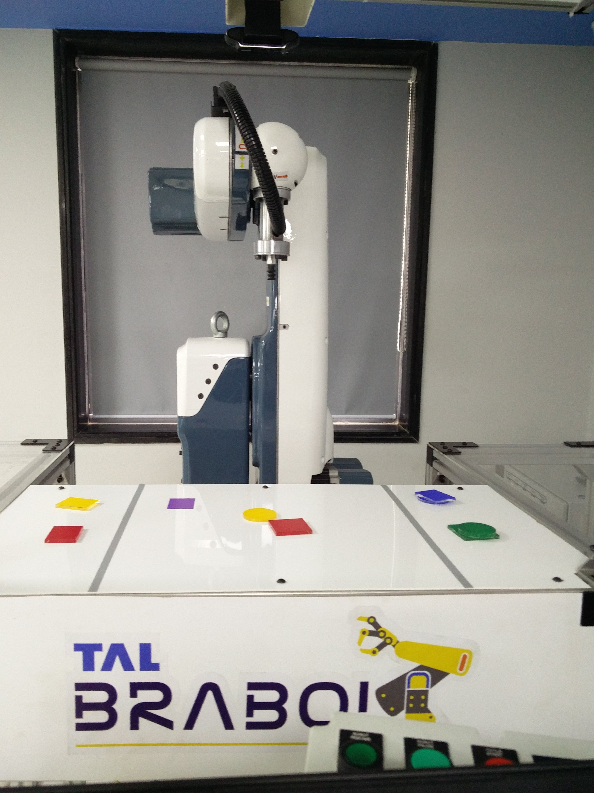

1. Click on the **Home** button. (Home tab will be disabled if homing is already done. Then only you can proceed working on any of the cells.)
2. A pop up message will be displayed to ask if the system is ready for the homing process. Click yes.
3. Wait until the homing process is completed. After homing has been completed, robot will face the table.
4. The system is ready to use voice control application through GUI window or to do programming by using teach pendant.

# **Operating Teach Pendant**

1. Teach pendant will get on along with robot controller and other components.
2. The robot programming window will open on the teach pendant. Otherwise on the desktop, click on teachpendant.exe and enter the password- “tal123” for admin profile.
3. Click on new program or open program as per the need.

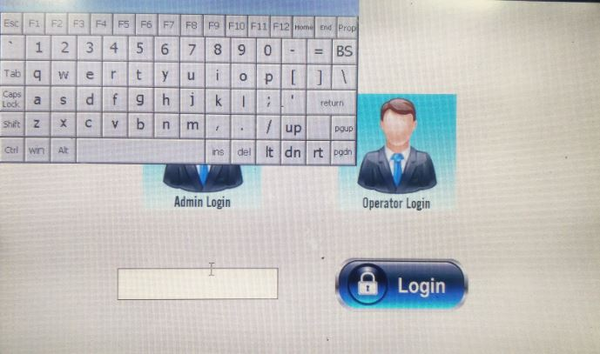

1. Go to ‘jog’ window on the teach pendant to jog the robot.
2. For jogging of the robot, move the black knob on teach pendant to ‘manual’ position (in anti-clockwise direction).

**Note:** Homing must be performed before performing any programming task on the robot.



Manual/ Idle/ Auto modes

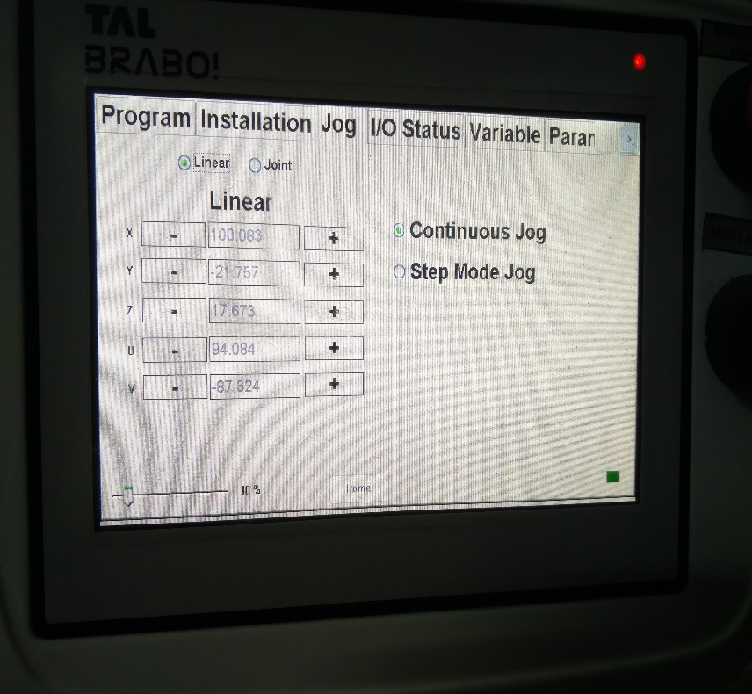 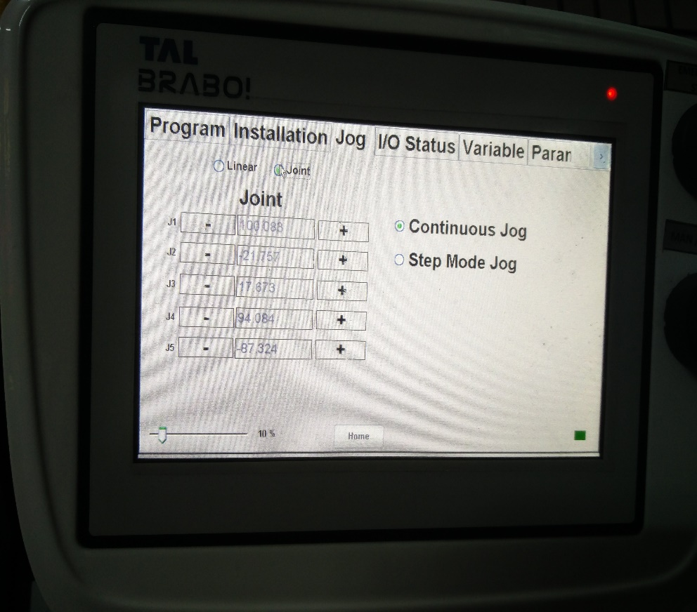

Linear mode selection for jogging Joint mode selection for jogging

1. In the ‘program’ window, one can use various robot commands available on teach pendant to program the robot for any pick and place operation.
2. After programming is done, go to installation tab and select save project. Save the project with some name.
3. After saving, go to program tab again and select “robot program” and then on “command”.

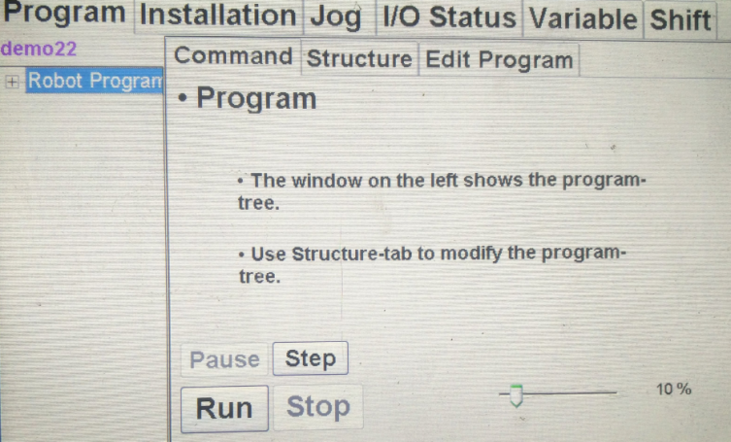

1. Turn the black knob on teach pendant to “auto mode” (clockwise direction). “Run” option will be displayed in that window.
2. The robot program will go on endlessly unless you click on “stop” displayed in the teach pendant or operator box.

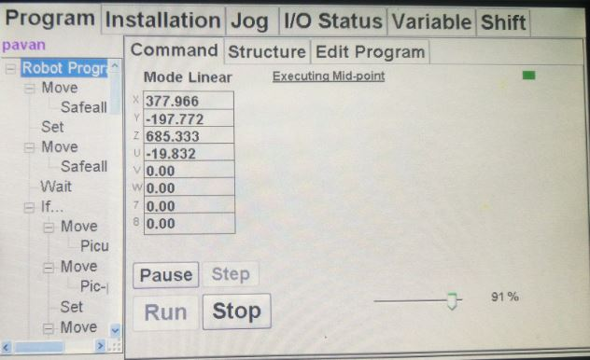

1. You can even pause and resume the program using the relevant icons on teach pendant and operator box.